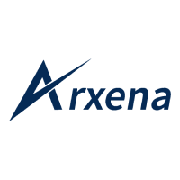

Chief Executive Officer – A publicly listed Industrial Manufacturing Company

Job Description Flyer

January 2025

**For Arxena Inc**

Arnav Saxena

[arnav@arxena.com](mailto:arnav@arxena.com)

+918411937769

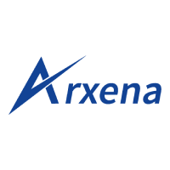

# The Opportunity

# An excellent opportunity to work with one of the industry leaders & fastest growing conglomerates in the industrial manufacturing space

# You will work very closely with business heads to drive organization growth in the coming decade

# Client Overview

### Our client is a leading player in the industrial manufacturing sector, renowned for its commitment to excellence and innovation. With a legacy spanning decades, the company has established itself as a prominent manufacturer and exporter of high-quality industrial products, serving a diverse clientele across the globe. Known for its state-of-the-art manufacturing capabilities and cutting-edge R&D, our client is poised for further growth and is seeking a dynamic and experienced CEO to lead the organization into its next phase of success.

# Role Overview

### This is a full-time on-site role for a Chief Executive Officer (CEO) of a publicly listed entity in the Industrial Manufacturing sector. The CEO will be responsible for overseeing finance, operations management, business planning, sales, and strategic planning on a day-to-day basis.

### Designation: CEO (Board Role)

### Location : Abu Road, Rajasthan

### Reports To : CMD

### Key Requirements

* Finance, Business Planning, and Strategic Planning skills
* Experience in the industrial manufacturing sector is required
* Operations Management expertise
* Sales acumen
* Strong analytical and problem-solving skills
* Leadership and decision-making abilities
* Excellent communication and interpersonal skills
* Bachelor's or Master's degree in Mechanical / Industrial Engineering/ Business Administration, Finance, or related field

### Requirements

* A pivotal leadership role in a prestigious and forward-thinking organization.
* A competitive compensation package, including performance-based incentives.
* The chance to lead a high-performing team and shape the future of a company with a strong legacy of success.
* A supportive and collaborative work environment that fosters innovation and professional growth.